**Practical-1**

**Aim: Write a C program to count the frequency of each character in a string.**

**Program:**

#include<stdio.h>

main()

{

char a[100];

int i,j,k,count,n;

printf("=> Enter the string : ");

gets(a);

for(j=0;j<=a[j];j++);

n=j;

printf("\n\n=> Frequency count in string :- \n");

for(i=0;i<n;i++)

{

count=1;

if(a[i])

{

for(j=i+1;j<n;j++)

{

if(a[i]==a[j])

{

count++;

a[j]='\0';

}

}

printf(" \n %c = %d ",a[i],count);

}

}

}

**Output:**

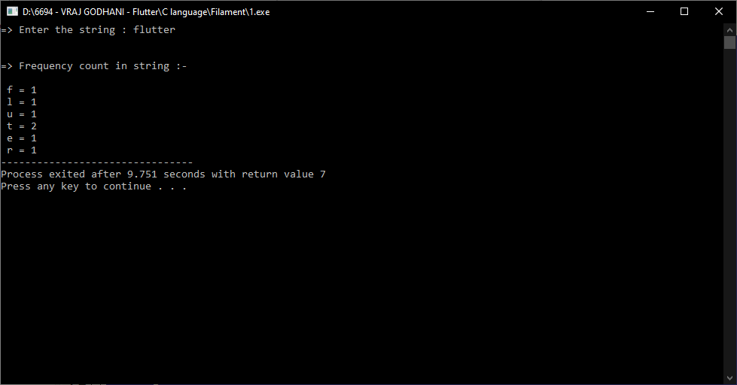

**Practical-2**

**Aim: Write a C program to check whether a string is a palindrome or not.**

**Program:**

#include <stdio.h>

main()

{

char a[100];

int i,n,c=0;

printf("=> Enter the string :- ");

gets(a);

n=strlen(a);

for(i=0; i<n/2; i++)

{

if(a[i]==a[n-i-1])

c++;

}

if( c == i )

{

printf("\n=> This string is palindrome.");

}

else

{

printf("\n=> This string is not palindrome.");

}

}

**Output:**

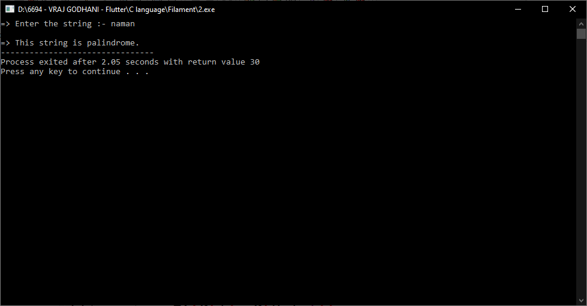

**Practical-3**

**Aim: Write a C program to remove spaces, blanks from a string.**

**Program:**

#include<stdio.h>

main()

{

char a[100];

int i=0,j,check;

printf("=> Enter any string :- ");

gets(a);

while(a[i]!='\0')

{

check=0;

if(a[i]==' ')

{

j=i;

while(a[j-1]!='\0')

{

a[j] = a[j+1];

j++;

}

check = 1;

}

if(check==0)

i++;

}

printf("\n=> String without spaces: %s",a);

}

**Output:**

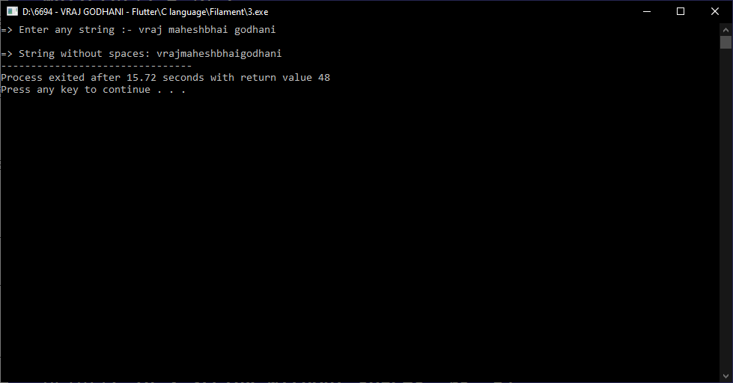

**Practical-4**

**Aim: Write a C program to remove all repeated characters in a string.**

**Program:**

#include <stdio.h>

main()

{

char a[100];

int i,j,k;

printf("=> Enter any string : ");

gets(a);

for(i=0; i<strlen(a); i++)

{

for(j=i+1; a[j]!='\0'; j++)

{

if(a[j]==a[i])

{

for(k=j; a[k]!='\0'; k++)

{

a[k] = a[k + 1];

}

}

}

}

printf("\n => String after remove duplicate charactor = %s ", a);

}

**Output:**

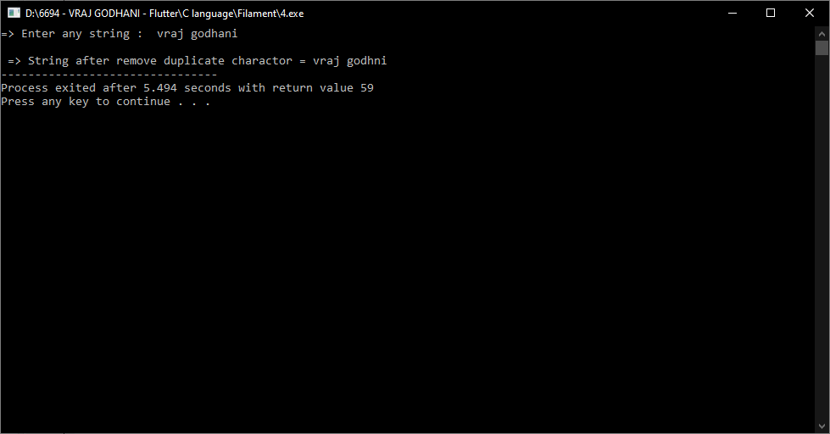

**Practical-5**

**Aim: Write a C program to check if a given string is a valid password or not by satisfying given criteria:**

**a. A password must be at least 6 characters long.**

**b. A password must contain at least one alphabet, one digit, and a special character.**

**c. Confirmation password feature must be available for double-checking.**

**Print Valid Password if a password satisfies all given criteria, otherwise print Invalid Password.**

**Program:**

**Output:**